Implementation of a Web-Camera Based Home Automation Solution Using Image Comparison

Joel Richard Saldanha, Shomik Mullick *guided by,*

Dept. of Instrumentation Technology Dr. C. H. Renumadhavi,

R.V. College of Engineering Professor, Dept. of Instrumentation Technology,

Bangalore- 560059 R.V. College of Engineering, Bangalore - 560059

***Abstract*: Home Automation is still a novelty especially in South East Asian countries and it not yet a fully successful commercial product. In this paper we present an alternative solution. We have developed a concept where we use a Web-camera instead of an IR sensor but instead of using image processing, which requires more processing power and has a greater lag, we use the concept of image comparison, a simpler and more cost effective alternative.**

I. INTRODUCTION

Home automation is the residential equivalent of automation in buildings and large constructions. It is the process of automating your house or home and other related residential activities. This includes centralized control of lighting, heating and air conditioning systems, control of appliances, control of security locks of gates and doors and other systems which can provide a high level of comfort, convenience, energy saving and security to consumers. In terms of lighting control, it is possible to save energy when installing various products.

Control systems for lighting can be used to control household electric bulbs and tubes. Examples include:

* Extinguishing all the lights of the house at a predetermined time and date range as specified by the user.
* Use of motion detectors to automatically e the lights in a room and turn on the lights depending on the presence and absence of people in the room.
* Turning the light on/off with the use of a remote wireless IR device.
* Control the brightness of the lights in the house according to the present ambient light level available or other criteria.
* Change the ambient colour of a room by varying the intensity of the lights or by using Red Green or Blue LEDs (mood control).

A. *Motivation*

The world today is in a serious energy crisis. Research in alternate fuel and power sources are a forefront in research.

One of the main concerns is the generation of electricity, which is a much needed commodity in our daily life. All of us have the habit of leaving lights and fans ON whenever we leave a room or take it for granted that someone else would switch them off for us. One person doing this may seem alright, but imagine millions of others doing the same and we see that it’s an ever growing problem. This is basically a waste of the electricity we generate and it increases the gap between supply and demand of power. In terms of lighting control, it is possible to conserve energy when we install various products. Simple devices such as motion sensors and human detectors can be built into a relatively straightforward home automation system can save huge amounts of wasted energy in both residential and office/commercial applications. For example imagine an automatic on/off at night time in all large office buildings, say after 9pm. When no presence is detected, lights and fans shut down, and the owner could save kilowatts of otherwise waste energy. A simple solution is the use of Home Automation which essentially means automation of a home, housework or any household activity.

B. *Research Gap*

Most home automation solutions include the use of a universal remote to control all lights and fans and other gadgets in the house using the principle of RF. Even the solutions that aim to automatically switch on and off lights and fan have been implemented using IR sensors. This is a cheap solution but suffers from the drawback of being unable to distinguish between different species, for e.g. between humans and dogs/pets.

II. CURRENT DEBATE

A. ***Interactive remote control of home appliances through a virtually wired sensor network:*** It is essentially a wireless network protocol and a control device, which make it possible to control legacy home appliances in an interactive way. The proposed wireless network protocol provides a bidirectional communication channel between a gateway and control devices. The control device hooked up to the wireless network controls a legacy home appliance requested by a user using IR signals and returns the result of the control action as a digested image so that the user can determine if the control operation has been conducted properly. [1]

B. ***A new method combining HOG (Histogram of Gradients) and Kalman filter for video-based human detection and tracking***: a novel approach is proposed for human detection and tracking in this paper [2] is first, improved HOG is used to extract human features in the image. Second, we make the relationship between human detection and tracking closer-detection is not only the prerequisite of tracking and it also benefits from tracking. Finally, the Kalman filter is introduced into detecting and tracking people. Our experiments have demonstrated that such a method reduces detection time, and improves human detection and tracking accuracy. [2]

C. ***Ubiquitous access to home appliance control system using infrared ray:*** Home appliance control system is a legitimate need of people nowadays. Digital home providers like to install their own network and provide home network enabled appliances and fixtures. It implies customers need to replace existing appliances with new expensive home network enabled appliance. In this paper, a simple but reliable approach to control home appliances and fixtures is presented. In this approach, we use infrared ray and power line communication integration in our home appliances control system. This system supports the ubiquitous access control mechanism which enables users to check their appliances' statuses and control them remotely. [3]

III. PROPOSED SOLUTION

A solution to this problem is to automate the process of switching ON and OFF the lights and fans in a home or office environment and this can also be extended to the operation of other appliances. This is a small yet, significant solution. We have analysed the different ways in which home automation is carried out and the different solutions that are commercially available today and we have developed a different technique of carrying out the same. We have come up with a concept of using a Webcam (which does the job of the sensor in our solution) and image comparison algorithms to develop a simple and yet effective Home Automation Solution.

IV. BASIC COMPONENTS

A. *Web-Camera*

This can be a simple web-camera which is often used for online purposes like video chatting. A 720p resolution web-camera is recommended. Also it required that the web-camera use USB as a means of connection.

B. *Raspberry Pi Controller*

The **Raspberry Pi** is a credit-card-sized single board computer. It works on a Linux based operating system platform. The Raspberry Pi has a Broadcom BCM2835 SoC, controlled by the latest generation ARM Processor. It is one of the most versatile devices on the market.

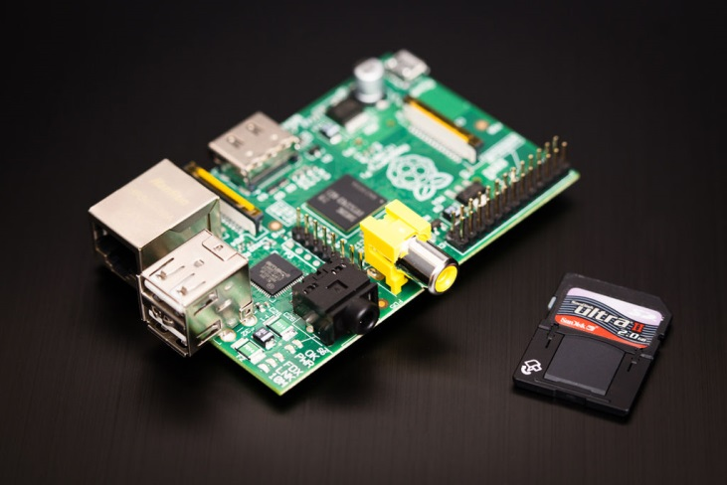

Fig: Raspberry Pi (courtesy www.raspberrypi.org)

C. *Circuitry*

A combination of relays and resistors make up the circuitry which is used to control the lights with respect to the signals given by the controller. The fans will in addition require a temperature sensor and depending on ambient temperature (comparison done using a LM328 comparator) the fan switches on/off.

V. METHODOLOGY

Essentially there are three main components as explained above. The webcam serves as the input interface between the environment and the controller. It is used to compare images of objects entering and leaving a room with respect to a host of reference images. There are a set of positive images and a set of negative images against which the input data is compared. The webcam output is given to the Raspberry Pi which houses the image comparison codes. The Raspberry Pi basically serves as the processing unit and has the reference images and the comparison algorithms programmed into it. The output of the Raspberry Pi is digital/analog in nature and is given to the external electrical circuit which is used to control the operation of the light. Furthermore, in order to control the fan, we make use of a LM328 comparator. If the input crosses the reference input, the comparator turns ON, and the fan is switched ON.

*Fig1: Block Diagram of the proposed idea*

VI. EXPECTED RESULTS

**Phase-1:** Control of lights depending on ambient light. When the person enters a room if ambient light is too low then the light is switched on and when he leaves the room the light is switched off automatically.

**Phase-2:** Control of fans depending on ambient temp. If the temp is about a preset minimum then the fan is switched on.

VII. REFERENCES

1. Interactive remote control of legacy home appliances through a virtually wired sensor network by Hyung-Bong Lee, Dept. of Computer Sci. & Eng., Gangneung-Wonju Nat. Univ., Gangneung, South Korea - IEEE Transactions on Consumer Electronics volume 58, issue 4. 2012.
2. A new method combining HOG and Kalman filter for video-based human detection and tracking by Changyan Li, Res. Inst. of Computer Science. & Technol., Ningbo Univ., Ningbo, China - 3rd International Congress on Image and Signal Processing (CISP), 2010.
3. Ubiquitous access to home appliance control system using infrared ray and power line communication by Tam Van Nguyen, Dept. of Computer Eng., Chonnam Nat. Univ., Gwangju - Internet, 2007. ICI 2007. 3rd IEEE/IFIP International Conference in Central Asia.